Muster GmbH
Erika Muster
Musterstr. 123
12345 Musterstadt

Musterstadt, 15.11.2018

Application as a bricklayer

Dear Mrs. Muster,
In 2017 I completed my GCSEs. I was made aware of the position for an apprentice in your establishment by one of my friends. I am very interested in a training for becoming a bricklayer because the handcraft fascinates me. Furthermore, I enjoy manufacturing and building something with my own hands, which is given in this profession.
Carrying out the training in a large company like yours is a great opportunity to work in various areas and to learn a lot.
Moreover, I am convinced that I fit in your company very well. Sports activities such as handball helped me develop and improve both the ability to work in a team and to be independent. I am certain that I can further increase my ambition, which I built doing sports, in work life. For this reason, I will be a reliable employee and quickly make efforts.
After detailed research, I am convinced that your company is outstanding. If I convinced you as well I will be pleased to get to know you in a personal interview.
Yours sincerely,
Lukas Kaiser

Unsere Empfehlung:

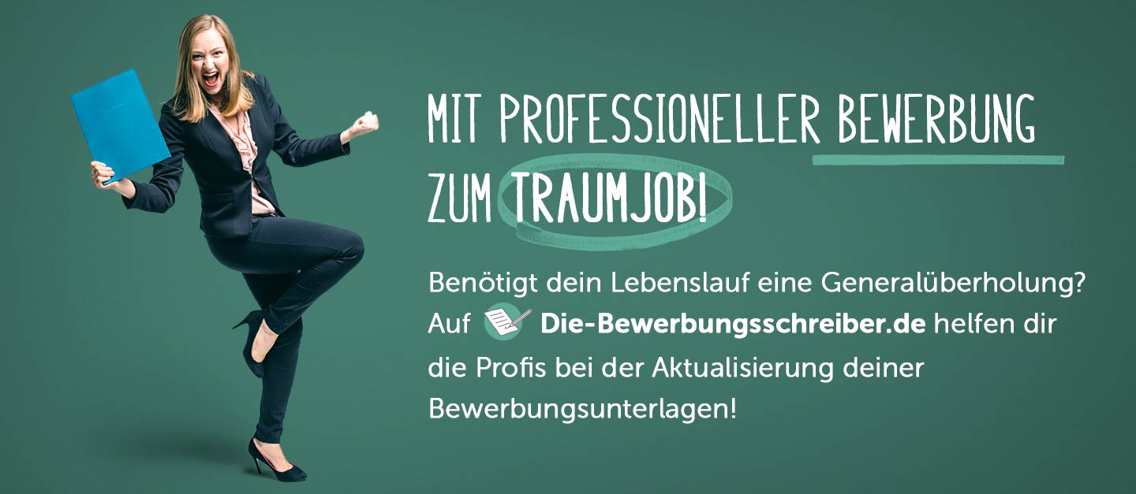

www.die-bewerbungsschreiber.de

