Muster GmbH
Erika Muster
Musterstr. 123
12345 Musterstadt

Musterstadt, 15.11.2018

Application as cosmetician

Dear Mrs. Muster,
After our intensive, friendly telephone conversation last week I would like to present my application documents as agreed. I researched on and informed myself intensively about your beauty parlour.
In contrast to other parlours you offer your customers a wide range of beauty treatments which allows the apprentice to gain practical experience. I am a person that is always eager to learn and therefore this aspect convinced me to apply for a training in your establishment. I would be very pleased to become a part of your young and innovative team.
Currently I am going to the XXX-High school and will obtain my degree in June 2014. My marks in scientific subjects such as chemistry and biology are outstanding. The reasons for my aspiration in this career come from personal experience. During puberty, I had problems with my skin and therefore saw myself confronted with different kinds of beauty products at an early age. After completing a four-week internship in the beauty parlour “Maria” I was further encouraged to become a cosmetician. This profession offers various tasks and a constant contact to customers which I find particularly interesting. I work conscientiously and precisely. In addition I am a communicative, open-minded and reliable person.
I would be happy if I aroused your interest. Of course I am available at any time to do an internship in your establishment before starting the training.
Yours sincerely,

Lukas Kaiser

Unsere Empfehlung:

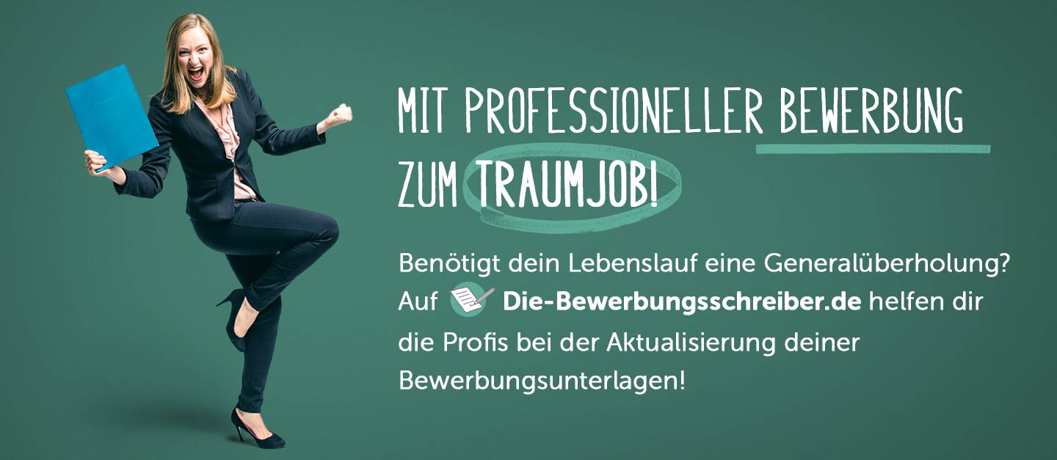

www.die-bewerbungsschreiber.de

